**RIBCAGE SOLUTIONS, INC. EXTENSIVE INVESTOR INQUIRY DOCUMENT**

§1 - Georgia Market Overview - Market Research

1. TAM analysis

Total Addressable Market of GA =

(# of prods in GA)(# of rain weeks/year)(average rental service)(Cost/unit/production)

= $6,750,000/year (in GA)

* 1. # of prods in GA/yr = 450 [1]
  2. # of rain weeks/year = 26/52 [2]
  3. Avg # of Ribcages needed/production in GA = 2 [3]
  4. Rental Revenue per ARCANGEL kit per show = $15,000

1. Serviceable Available Market (SAM) analysis
2. The SAM of GA is likely about *half of the TAM* (=$3,375,000/yr). Not every production will have enough shoot days inside with outside power to motivate renting a ARCANGEL kit.
3. Serviceable Obtainable Market (SOM) Roadmap
   1. Depends on how many productions we can reach out to.
      1. Difficult to reach UPMs
         1. Need connections
   2. We expect to reach every major studio within our first year of operation, thereby putting all studio productions within our SAM. This does not, however, guarantee that each production is in our SOM because the decision to rent an ARCANGEL kit is initially up to the UPM and decided on a per-shoot-week-per-production basis. Later on, we expect studios themselves to expand their budgeting policies in production manuals based on Ribcage’s value-add to crew safety and lightning related exposure.
      1. The general plan to reach studios is as follows: once the new CSATF Bulletin regarding Lightning events comes out (Early 2024), we will initiate contact with Universal. This point of contact is currently being set up by a highly regarded industry professional with a working relationship with a safety executive at Universal who is supportive of various means to reduce lightning exposure. Our argument is: even though the bulletin comes out and technically changes the regulations and SOP allowing the use of generator cages, the actuality is that crews will not want to do things differently unless the studio issues a directive and clears it on an internal SOP level. So, the studio’s best interest is actually to work directly with RC in the implementation of the new SOP. Assuming the studio accepts this compelling rationale, the next plausible step will be for the studio contact in safety to have a willingness to connect us to their UPMs on each show in order to ensure ARCANGEL kits are rented and deployed. This approach ensures RC becomes a preferred vendor at each studio while also ensuring the studios connect RC with their productions, at an SOP level (the same way other rental companies are).

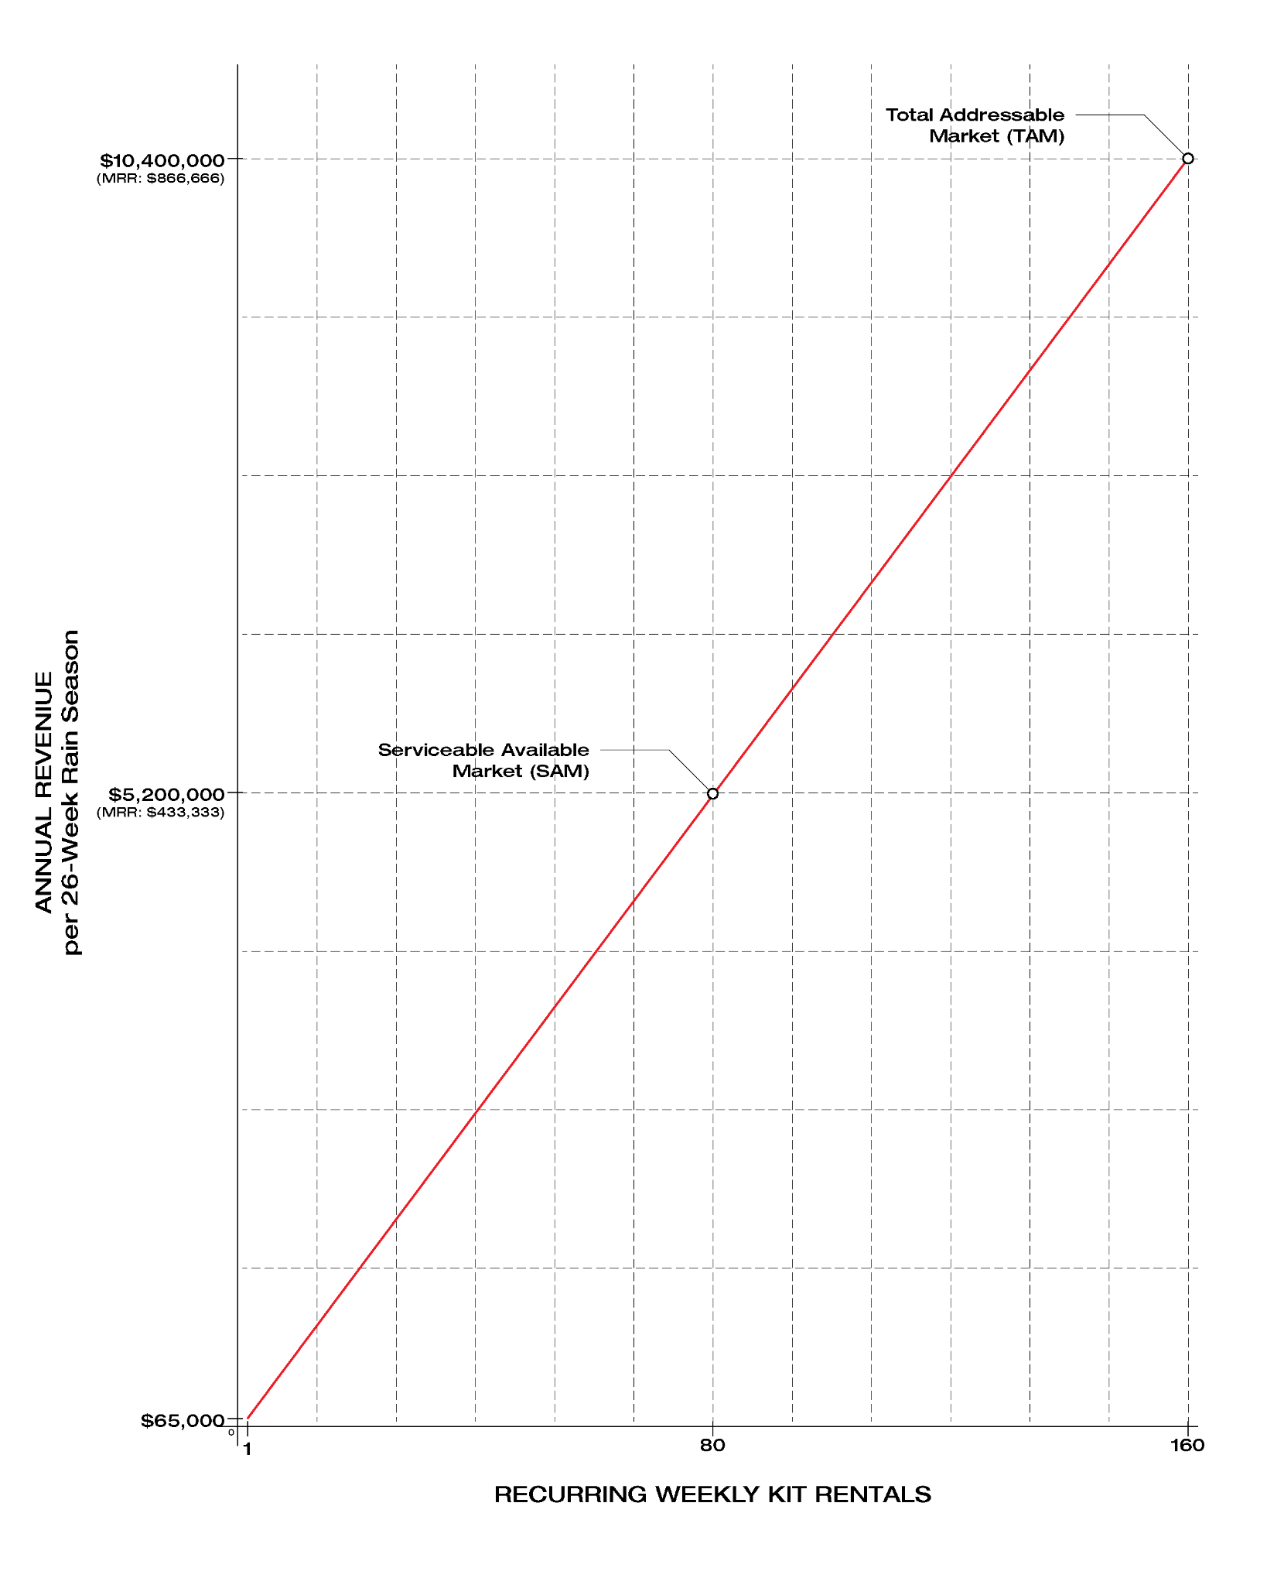

§2 - Supply Chain Management

1. Supply chain costs
   1. The supply chain costs/kit vary greatly depending on the mixture of materials to achieve the LPS. For this reason, we will be listing each individual part on its own and then listing the cost per kit.

| **AIR TERMINALS (AT)** | | | | | | | | | | | |
| --- | --- | --- | --- | --- | --- | --- | --- | --- | --- | --- | --- |
| REGION/SECTOR | SUPPLIER (MANUFACTURER) | PART | MOQ | OOQ | Price/Part/MOQ | Price/Part/OOQ | Lead Time | Kits/MOQ | Kits/OOQ | Cost/Kit/MOQ | Cost/Kit/OOQ |
| RETAIL, US | GORDON (HARGER) | AT-COPPER, 48"x1/2" | 1 | 4 | 93.09 | 93.09 | 2 weeks | 0.25 | 1 | NA | 372.36 |
| WHOLESALE, US | ONE-SOURCE (HARGER) | AT-COPPER, 48"x1/2" | 1 | 4 | 66.79 | 66.79 | 2-3 weeks | 0.25 | 1 | NA | 267.16 |
| WHOLESALE, US | ONE-SOURCE (HARGER) | AT-ALUMINUM, 48"x12" | 1 | 4 | 13.72 | 13.72 | 2-3 weeks | 0.25 | 1 | NA | 54.88 |
| WHOLESALE, US | ONE-SOURCE (ERICO) | AT-COPPER, 48"x1/2" | 1 | 4 | 63.69 | 63.69 | (2-3 weeks) | 0.25 | 1 | NA | 254.76 |
| WHOLESALE, US | ONE-SOURCE (ERICO) | AT-ALUMINUM, 48"x12" | 1 | 4 | 16.75 | 16.75 | (2-3 weeks) | 0.25 | 1 | NA | 67 |

| **EXTENSION RODS (ER)** | | | | | | | | | | | |
| --- | --- | --- | --- | --- | --- | --- | --- | --- | --- | --- | --- |
| REGION/SECTOR | SUPPLIER (MANUFACTURER) | PART | MOQ | OOQ | Price/Part/MOQ | Price/Part/OOQ | Lead Time | Kits/MOQ | Kits/OOQ | Cost/Kit/MOQ | Cost/Kit/OOQ |
| RETAIL, US | GORDON (HARGER) | ER-COPPER, 48"x1/2" | 1 | 8 | 85.09 | 85.09 | 2 weeks | 0.125 | 1 | NA | 680.72 |
| RETAIL, US | GORDON (HARGER) | ER-COPPER, 12"x5/8" | 1 | 54 | 35.09 | 35.09 | 2 weeks | 0.01851851852 | 1 | NA | 1894.86 |
| WHOLESALE, US | ONE-SOURCE (HARGER) | ER-COPPER, 48"x1/2" | 1 | 8 | 94.33 | 94.33 | 2-3 weeks | 0.125 | 1 | NA | 754.64 |
| WHOLESALE, US | ONE-SOURCE (HARGER) | ER-COPPER, 12"x5/8" | 1 | 54 | 38.79 | 38.79 | 2-3 weeks | 0.01851851852 | 1 | NA | 2094.66 |
| WHOLESALE, US | ONE-SOURCE (HARGER) | ER-COPPER, 36"x5/8" | 1 | 18 | 108.59 | 108.59 | 2-3 weeks | 0.05555555556 | 1 | NA | 1954.62 |
| WHOLESALE, US | ONE-SOURCE (HARGER) | ER-ALUMINUM, 60"x1/2" | 1 | 4 | 30.51 | 30.51 | 2-3 weeks | 0.25 | 1 | NA | 122.04 |
| WHOLESALE, US | ONE-SOURCE (HARGER) | ER-COPPER, 12"x1/2" | 1 | 4 | 23.34 | 23.34 | (2-3 weeks) | 0.25 | 1 | NA | 93.36 |
| WHOLESALE, US | ONE-SOURCE (ERICO) | ER-COPPER, 48"x1/2" | 1 | 8 | 85.08 | 85.08 | (2-3 weeks) | 0.125 | 1 | NA | 680.64 |
| WHOLESALE, US | ONE-SOURCE (ERICO) | ER-COPPER, 12"x5/8" | 1 | 54 | 24.62 | 24.62 | (2-3 weeks) | 0.01851851852 | 1 | NA | 1329.48 |
| WHOLESALE, US | ONE-SOURCE (ERICO) | ER-COPPER, 36"x5/8" | 1 | 18 | 73.86 | 73.86 | (2-3 weeks) | 0.05555555556 | 1 | NA | 1329.48 |
| WHOLESALE, US | ONE-SOURCE (ERICO) | ER-ALUMINUM, 72"x1/2" | 1 | 4 | 86.82 | 86.82 | (2-3 weeks) | 0.25 | 1 | NA | 347.28 |
| WHOLESALE, US | ONE-SOURCE (ERICO) | ER-COPPER, 12"x1/2" | 1 | 4 | 21.27 | 21.27 | (2-3 weeks) | 0.25 | 1 | NA | 85.08 |

| **AUXILIARY PARTS** | | | | | | | | | | | |
| --- | --- | --- | --- | --- | --- | --- | --- | --- | --- | --- | --- |
| REGION/SECTOR | SUPPLIER (MANUFACTURER) | PART | MOQ | OOQ | Price/Part/MOQ | Price/Part/OOQ | Lead Time | Kits/MOQ | Kits/OOQ | Cost/Kit/MOQ | Cost/Kit/OOQ |
| RETAIL, US | GORDON (ERICO) | ROD CLAMP | 50 | 50 | 2.39 | 2.39 | 2 weeks | 3.125 | 3.125 | 38.24 | 38.24 |
| RETAIL, US | GORDON (HARGER) | COPPER COUPLER 5/8"x5/8" | 1 | 50 | 9.59 | 9.59 | 2 weeks | 0.02 | 1 | NA | 479.5 |
| RETAIL, US | GORDON (HARGER) | COPPER COUPLER 1/2"x1/2" | 1 | 8 | 9.59 | 9.59 | 2 weeks | 0.125 | 1 | NA | 76.72 |
| WHOLESALE, US | ONE-SOURCE (ERICO) | ROD CLAMP | 1 | 16 | 3.25 | 3.25 | (2-3 weeks) | 0.0625 | 1 | NA | 52 |
| WHOLESALE, US | ONE-SOURCE (ERICO) | COPPER COUPLER/ADAPTER 1/2"x1/2" | 1 | 4 | 15.28 | 15.28 | (2-3 weeks) | 0.25 | 1 | NA | 61.12 |
| WHOLESALE, US | ONE-SOURCE (ERICO) | COPPER COUPLER/ADAPTER 5/8"x5/8" | 1 | 14 | 15.92 | 15.92 | (2-3 weeks) | 0.07142857143 | 1 | NA | 222.88 |
| WHOLESALE, US | ONE-SOURCE (ERICO) | ALUMINUM COUPLER/ADAPTER 1/2"x1/2" | 1 | 4 | 12.22 | 12.22 | (2-3 weeks) | 0.25 | 1 | NA | 48.88 |
| WHOLESALE, US | ONE-SOURCE (HARGER) | ROD CLAMP | 1 | 16 | 4.09 | 4.09 | 2-3 weeks | 0.0625 | 1 | NA | 65.44 |
| WHOLESALE, US | ONE-SOURCE (HARGER) | BRASS COUPLER 5/8"x5/8" | 1 | 14 | 10.54 | 10.54 | 2-3 weeks | 0.07142857143 | 1 | NA | 147.56 |
| WHOLESALE, US | ONE-SOURCE (HARGER) | BRASS COUPLER 1/2"x1/2" | 1 | 4 | 10.54 | 10.54 | 2-3 weeks | 0.25 | 1 | NA | 42.16 |
| WHOLESALE, US | ONE-SOURCE (HARGER) | ALUMINUM COUPLER 1/2"x1/2" | 1 | 4 | 5 | 5 |  | 0.25 | 1 | NA | 20 |

| **GROUNDING** | | | | | | | | | | | |
| --- | --- | --- | --- | --- | --- | --- | --- | --- | --- | --- | --- |
| REGION/SECTOR | SUPPLIER (MANUFACTURER) | PART | MOQ | OOQ | Price/Part/MOQ | Price/Part/OOQ | Lead Time | Kits/MOQ | Kits/OOQ | Cost/Kit/MOQ | Cost/Kit/OOQ |
| WHOLESALE, US | ONE-SOURCE (ERICO) | COPPER CONDUCTOR-50FT | 1 | 2 | 142 | 142 | (2-3 weeks) | 0.5 | 1 | NA | 284 |
| WHOLESALE, US | ONE-SOURCE (ERICO) | COPPER GROUNDING PLATE 12"x24" | 1 | 2 | 188.26 | 188.26 | (2-3 weeks) | 0.5 | 1 | NA | 376.52 |
| WHOLESALE, US | ONE-SOURCE (HARGER) | COPPER CONDUCTOR-50FT | 1 | 2 | 225.129 | 225.129 | 2-3 weeks | 0.5 | 1 | NA | 450.258 |
| WHOLESALE, US | ONE-SOURCE (HARGER) | COPPER GROUNDING PLATE 12"x12" | 1 | 2 | 154.99 | 154.99 | 2-3 weeks | 0.5 | 1 | NA | 309.98 |

| **CORNER BLOCKS** | | | | | | | | | | | |
| --- | --- | --- | --- | --- | --- | --- | --- | --- | --- | --- | --- |
| REGION/SECTOR | SUPPLIER (MANUFACTURER) | PART | MOQ | OOQ | Price/Part/MOQ | Price/Part/OOQ | Lead Time | Kits/MOQ | Kits/OOQ | Cost/Kit/MOQ | Cost/Kit/OOQ |
|  | ERICOMFG (ERICOMFG) | BRASS 2.5"x2.5" | 4 | 100 | 140 | 52 | (1-2 weeks) | 1 | 25 | 560 | 208 |

* 1. Below are the kit cost tables. Kit tables 1-3 are for All-Copper and 4-6 are for bi-metallic. Our optimal Kit order is Table 6.

| KIT-1: GORDON ALL-COPPER (HARGER+ERICO) | | | | |
| --- | --- | --- | --- | --- |
| MANUFACTURER | PART | QUANTITY/KIT | UNIT PRICE | PART-COST/KIT |
| HARGER | AT-COPPER, 48"x1/2" | 4 | 93.09 | 372.36 |
| HARGER | ER-COPPER, 48"x1/2" | 8 | 85.09 | 680.72 |
| HARGER | ER-COPPER, 12"x5/8" | 54 | 35.09 | 1894.86 |
| ERICO | ROD CLAMP | 16 | 2.39 | 38.24 |
| HARGER | COPPER COUPLER 5/8"x5/8" | 50 | 9.59 | 479.5 |
| HARGER | COPPER COUPLER 1/2"x1/2" | 8 | 9.59 | 76.72 |
| ERICCOMFG | BRASS 2.5"x2.5" | 4 | 140 | 560 |
|  | [GROUNDING NOT FROM GORDON] |  |  | 0 |
| ERICO | COPPER CONDUCTOR-50FT | 2 | 142 | 284 |
| HARGER | COPPER GROUNDING PLATE 12"x12" | 2 | 154.99 | 309.98 |
|  | | | TOTAL | 4696.38 |

| KIT-2: ONESOURCE ALL-COPPER (HARGER ONLY) | | | |
| --- | --- | --- | --- |
| PART | QUANTITY/KIT | UNIT PRICE | PART-COST/KIT |
| AT-COPPER, 48"x1/2" | 4 | 66.79 | 267.16 |
| ER-COPPER, 48"x1/2" | 8 | 94.33 | 754.64 |
| ER-COPPER, 36"x5/8" | 18 | 108.59 | 1954.62 |
| BRASS COUPLER 5/8"x5/8" | 14 | 10.54 | 147.56 |
| BRASS COUPLER 1/2"x1/2" | 8 | 10.54 | 84.32 |
| ROD CLAMP | 16 | 4.09 | 65.44 |
| BRASS 2.5"x2.5" | 4 | 140 | 560 |
| COPPER CONDUCTOR-50FT | 2 | 225.129 | 450.258 |
| COPPER GROUNDING PLATE 12"x12" | 2 | 154.99 | 309.98 |
|  | | TOTAL | 4593.978 |

| KIT-3: ONESOURCE ALL-COPPER (ERICO ONLY) | | | |
| --- | --- | --- | --- |
| PART | QUANTITY/KIT | UNIT PRICE | PART-COST/KIT |
| AT-COPPER, 48"x1/2" | 4 | 63.69 | 254.76 |
| ER-COPPER, 48"x1/2" | 8 | 85.08 | 680.64 |
| ER-COPPER, 36"x5/8" | 18 | 73.86 | 1329.48 |
| ROD CLAMP | 16 | 3.25 | 52 |
| COPPER COUPLER/ADAPTER 1/2"x1/2" | 8 | 15.28 | 122.24 |
| COPPER COUPLER/ADAPTER 5/8"x5/8" | 14 | 15.92 | 222.88 |
| BRASS 2.5"x2.5" | 4 | 140 | 560 |
| COPPER CONDUCTOR-50FT | 2 | 142 | 284 |
| COPPER GROUNDING PLATE 12"x24" | 2 | 188.26 | 376.52 |
|  | | TOTAL | 3882.52 |

| KIT-4: ONESOURCE ALUMINUM+COPPER (HARGER ONLY) | | | |
| --- | --- | --- | --- |
| PART | QUANTITY/KIT | UNIT PRICE | PART-COST/KIT |
| AT-ALUMINUM, 48"x12" | 4 | 13.72 | 54.88 |
| ER-ALUMINUM, 60"x1/2" | 4 | 30.51 | 122.04 |
| ER-COPPER, 12"x1/2" | 4 | 23.34 | 93.36 |
| ER-COPPER, 36"x5/8" | 18 | 108.59 | 1954.62 |
| BRASS COUPLER 5/8"x5/8" | 14 | 10.54 | 147.56 |
| BRASS COUPLER 1/2"x1/2" | 4 | 10.54 | 42.16 |
| ALUMINUM COUPLER 1/2"x1/2" | 4 | 5 | 20 |
| ROD CLAMP | 16 | 4.09 | 65.44 |
| BRASS 2.5"x2.5" | 4 | 140 | 560 |
| COPPER CONDUCTOR-50FT | 2 | 225.129 | 450.258 |
| COPPER GROUNDING PLATE 12"x12" | 2 | 154.99 | 309.98 |
|  | | TOTAL | 3820.298 |

| KIT-5: ONESOURCE ALUMINUM+COPPER (ERICO ONLY) | | | |
| --- | --- | --- | --- |
| PART | QUANTITY/KIT | UNIT PRICE | PART-COST/KIT |
| AT-ALUMINUM, 48"x12" | 4 | 16.75 | 67 |
| ER-ALUMINUM, 72"x1/2" | 4 | 86.82 | 347.28 |
| ER-COPPER, 12"x1/2" | 4 | 21.27 | 85.08 |
| ER-COPPER, 36"x5/8" | 18 | 73.86 | 1329.48 |
| ROD CLAMP | 16 | 3.25 | 52 |
| COPPER COUPLER/ADAPTER 1/2"x1/2" | 4 | 15.28 | 61.12 |
| COPPER COUPLER/ADAPTER 5/8"x5/8" | 14 | 15.92 | 222.88 |
| ALUMINUM COUPLER/ADAPTER 1/2"x1/2" | 4 | 12.22 | 48.88 |
| BRASS 2.5"x2.5" | 4 | 140 | 560 |
| COPPER CONDUCTOR-50FT | 2 | 142 | 284 |
| COPPER GROUNDING PLATE 12"x24" | 2 | 188.26 | 376.52 |
|  | | TOTAL | 3434.24 |

| KIT-6: ONESOURCE ALUMINUM+COPPER (ERICO+HARGER) | | | | |
| --- | --- | --- | --- | --- |
| MANUFACTURER | PART | QUANTITY/KIT | UNIT PRICE | PART-COST/KIT |
| HARGER | AT-ALUMINUM, 48"x12" | 4 | 13.72 | 54.88 |
| HARGER | ER-ALUMINUM, 60"x1/2" | 4 | 30.51 | 122.04 |
| ERICO | ER-COPPER, 12"x1/2" | 4 | 21.27 | 85.08 |
| ERICO | ER-COPPER, 36"x5/8" | 18 | 73.86 | 1329.48 |
| ERICO | ROD CLAMP | 16 | 3.25 | 52 |
| HARGER | BRASS COUPLER 5/8"x5/8" | 14 | 10.54 | 147.56 |
| HARGER | BRASS COUPLER 1/2"x1/2" | 4 | 10.54 | 42.16 |
| HARGER | ALUMINUM COUPLER 1/2"x1/2" | 4 | 5 | 20 |
| ERICCOMFG | BRASS 2.5"x2.5" | 4 | 140 | 560 |
| ERICO | COPPER CONDUCTOR-50FT | 2 | 142 | 284 |
| HARGER | COPPER GROUNDING PLATE 12"x12" | 2 | 154.99 | 309.98 |
|  | | | TOTAL | 3007.18 |

1. Supply Chain Expansion Roadmap
   1. Below are the tables for revenue, growth, goals in general, according to one 28 week “rain season”. Please note the “cumulative units rented” column acts as a key for operations goals once the average # units rented/wk is known. Accordingly, this column is a guide for establishing the way forward, no matter what the actual situation is in terms of units/rented/week. For example, if it takes 3 months to hit the *Week 6* goal of break even + living expenses + 50% of expansion cost, then we operate according to the week 6 goal.

| **Month/Month** | **Net** | Cost Notes | **Units Rented/wk** | **Cumulative Units Rented** | **Gross** | **Goal** |
| --- | --- | --- | --- | --- | --- | --- |
| ***Month 1 Start*** | **-$6,777** | Startup cost |  |  |  |  |
| Week 1 | -$4,417 |  | 1 | 1 | $2,640 |  |
| Week 2 | -$2,057 |  | 1 | 2 | $5,280 |  |
| Week 3 | $303 | Break even | 1 | 3 | $7,920 | Break even |
| Week 4 | $2,663 |  | 1 | 4 | $10,560 |  |
| ***Month 2*** |  |  |  |  |  |  |
| Week 5 | $2,123 | Cost of living subtracted | 1 | 5 | $13,200 |  |
| Week 6 | $718 | Kit 2 expansion | 1 | 6 | $15,840 | First expansion phase |
| Week 7 | -$687 | Kit 3 expansion | 1 | 7 | $18,480 | Second expansion phase |
| Week 8 | $1,673 |  | 1 | 8 | $21,120 |  |
| ***Month 3*** |  |  |  |  |  |  |
| Week 9 | $1,213 | Cost of living subtracted | 1 | 9 | $23,760 |  |
| Week 10 | $5,933 | Kit 2 start-work | 2 | 11 | $29,040 |  |
| Week 11 | $13,013 | Kit 3 start-work | 3 | 14 | $36,960 |  |
| Week 12 | $2,308 | add'tl 5 Kit Batch expansion | 3 | 17 | $44,880 | third expansion phase |
| ***Month 4*** |  |  |  |  |  |  |
| Week 13 | $6,488 | Cost of living subtracted | 3 | 20 | $52,800 |  |
| Week 14 | -$4,217 | add'tl 5 kit batch expansion #2 | 3 | 23 | $60,720 |  |
| Week 15 | $2,863 |  | 3 | 26 | $68,640 |  |
| Week 16 | $21,743 | 5 kit expansion start-work | 8 | 34 | $89,760 |  |
| ***Month 5*** |  |  |  |  |  |  |
| Week 17 | $5,053 | add'tl 10 kit batch expansion | 8 | 42 | $110,880 | 4th expansion phase |
| Week 18 | $35,733 | add'tl 5 kit batch expansion #2 start-work | 13 | 55 | $145,200 |  |
| Week 19 | $30,843 | add'tl 10 kit batch expansion #2 | 13 | 68 | $179,520 |  |
| Week 20 | $25,953 | add'tl 10 kit batch expansion #3 | 13 | 81 | $213,840 |  |
| ***Month 6*** |  |  |  |  |  |  |
| Week 21 | $39,263 | Cost of living subtracted, 10 kit xp start-work, add'tl 10 kit batch expansion #4 | 23 | 104 | $274,560 |  |
| Week 22 | -$48,737 | add'tl 40 kit expansion | 23 | 127 | $335,280 | SAM inventory reached (80), 5th expansion phase |
| Week 23 | $29,143 | 10 kit xp #2 start-work | 33 | 160 | $422,400 |  |
| Week 24 | $130,623 | 10 kit xp #3 start-work | 43 | 203 | $535,920 |  |
| ***Month 7*** |  |  |  |  |  |  |
| Week 25 | $172,803 | 10 kit xp #4 start-work, cost of living subtracted, cost of warehouse subtracted, cost of labor subtracted | 53 | 256 | $675,840 |  |
| Week 26 | $389,783 | add'tl 40 kit expansion start-work | 93 | 349 | $921,360 |  |
| Week 27 | $357,773 | add'tl 70 kit batch expansion | 93 | 442 | $1,166,880 | TAM inventory reached, 6th expansion phase (160) |
| Week 28 | $574,753 |  | 93 | 535 | $1,412,400 |  |
| **Operation Breakdown:** |  | **Gross Revenue by Week 28** | **$1,412,400** |  | **Hires** | **Salary** |
| SAM goal achieved @ 28 weeks |  | **Total Expenditures** | **$837,647** |  | Warehouse Worker | 52000/yr |
| 93 units rented, 163 units total  2 laborers, accountant, 1 warehouse |  | **Net Profit** | **$574,753** |  | Coordinator | 78000/yr |
| Rented warehouse @ 2500/mo, 3 hires |  | **Expected revenue of Y2** | **$5,200,000+** |  | Accountant | 75000/yr |

§3 - Startup Roadmap

1. Startup costs

Utility Patent

* + 1. Utility Patents can cost up to $20,000. We expect our utility patent to cost less than $10,000, but in the end it depends entirely on how many attorney office actions (appeals) are required to overcome USPTO rejections. We plan to allocate $10,000 up front to office actions to keep the patent-pending status during our initial growth period.

Operations in GA

* + 1. Housing @ <$2,500/mo
       1. Including garage storage space for unit inventory
       2. Small work space/2 people
       3. Small living space/2 people
       4. Utilities

Packaging

* + 1. We will use stackable bins with spray stencil branding.
       1. 1 bin per set of pieces per unit
          1. Rods = $30
          2. Auxiliary = $30
          3. Grounding = $30

= $90/unit inventory

Outbound Shipping

* + 1. Handled by Productions
       1. Productions usually do not ship heavy units in bulk, which Ribcages are (over 50lbs). They send transportation crew members to haul the equipment instead. We find it reasonable to expect GA based shows to pick up units from us. It is not uncommon for productions to pick up inventory from businesses based in peoples’ garages.

Return Shipping

* + 1. Handled by Productions
       1. Each production will disassemble their rentals, pack them into the original bins, and return the bins to our garage. They will then be inspected for losses and damages. These bins can and will be lost but we will charge L&D for the bins and call each production one week prior to return to ensure they have the correct number of bins. If necessary, we can drive bins to them ourselves.

Auxiliary Strategic Growth: Additional Revenue Stream Opportunity:

* + 1. All of the grounding conductors need to be encased in non-conductive protective shielding. This is usually achieved on productions via Yellowjacket cable protectors. 1-Channel Yellowjackets are about $45/3ft and grounding must take place a minimum of 20 ft away from the Ribcage. Two conductors means 40 ft total, which is 14 yellowjackets/Ribcage, giving us **$1260/kit in yellowjacket costs up front**. Vendors rent 5-Channel yellowjackets (which cost $300-400) @ $15/day, so it would be in our strategic interest to rent them out ourselves at a comparable cost of between $2-5/day/ea.

1. First Month Start-up Expenditures (based on sections 3a-c and supply chain chart)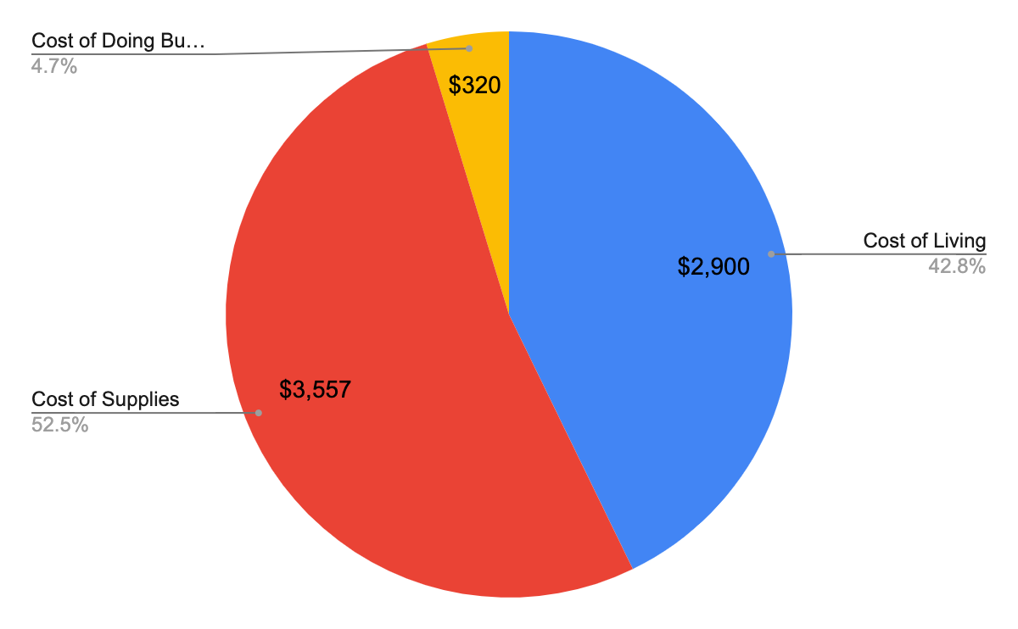

Breakdown of Costs

| **Cost of Living** | Price/Mo/Person | QTY |
| --- | --- | --- |
| Housing | $1,000 | 2 |
| Utilities | $100 | 2 |
| Food | $350 | 2 |
| Total | $2,900 |  |
| **Cost of Supplies** | Price | QTY |
| ARCANGEL kit | $3,000 | 1 |
| Yellowjackets | $467 | 1 |
| Packaging | $90 | 1 |
| Total | $3,557 |  |
| **Cost of Doing Business** | Price/Mo/Person |  |
| Internet | $100 |  |
| Productivity Subscriptions | $50 |  |
| Phone | $35 | 2 |
| Branding Supplies | $100 |  |
| Total | $320 |  |
| **Initial Startup Cost** | **$6,777** | addt'l 2900/mo living expenses |
| Initial kit revenue/wk | $2,500 |  |
| Cost for 5 kit expansion | $17,785 |  |
| **Final Total for Operation Start-up** | **$24,562** |  |

§4 - Risks

1. Risks

Fewer productions have a use for shooting inside during lightning storms than expected

* + 1. This is possible but, as an added safety measure, it’s also possible that each studio would calculate their exposure to lightning shutdowns and require all productions to shield their generators and HVAC units regardless of weather forecasts. This is not unreasonable because, for example, productions pay incredible amounts in life insurance for stars to cover liability to the entire loss of the project if one of the stars dies in a plane crash, specifically. Chance of a plane crash is 1/11,000,000 and chance of being struck by lightning is 1/300,000, so exposure to a plane crash is minimal compared to exposure to lightning shutdowns.Therefore, direct lightning strikes or side flashes (lightning arcs from object to object) are statistically much more likely to kill a star than a plane crash, so it’s in the interest of the production to do what they can to protect from this possibility.

§5 - Total Ask

1. The ask is $135k for 10%

We ask $135k to break down into start-up costs based on the following equation:

$4,000/kit(# of Starting Kits)

+

(living expenses per month)

x

(# of months to SAM inventory goal, 80, according to # of Starting Kits)

= optimal start-up investment to cover a slow growth rollout



Contact us

[info@ribcagesolutions.com](mailto:info@ribcagesolutions.com)

We look forward to hearing from you!

RIBCAGE SOLUTIONS INC. in no way provides or lays claim to any provision of any mode of insurance against lightning related events and assumes no liability for related damages, regardless of “protection” status, to items or people inside a RIBCAGE. We only claim that RIBCAGEs adequately ground generators for lightning strikes and that a lightning strike *should* be grounded by our system, although it is still possible for a lightning strike to overpower our lightning protection system or for other environmental factors to interfere with the effectiveness of lightning protection systems. RIBCAGEs are sold solely as a piece of equipment to satisfy conditions for generator related workplace safety when in a shelter during a lightning storm. Use at your own risk.

1. https://www.georgia.org/industries/film-entertainment/georgia-film-tv-production/now-filming-georgia
2. https://www.weather.gov/ffc/rainfall_scorecard
3. May be conservative. Unknown due to # of reality vs scripted productions. Depends on size of production and type of locations.